**Industrial Internship Report on**

**”Smart City”**

**Prepared by**

**Monisha P S**

|  |
| --- |
| *Executive Summary* |
| This report provides details of the Industrial Internship provided by upskill Campus and The IoT Academy in collaboration with Industrial Partner UniConverge Technologies Pvt Ltd (UCT).  This internship was focused on a project/problem statement provided by UCT. We had to finish the project including the report in 6 weeks’ time.  My project was working with the government to transform various cities into a smart city. The vision is to convert it into a digital and intelligent city to improve the efficiency of services for the citizens. One of the problems faced by the government is traffic. The government wants to implement a robust traffic system for the city by being prepared for traffic peaks.  This internship gave me a very good opportunity to get exposure to Industrial problems and design/implement solution for that. It was an overall great experience to have this internship. |

**TABLE OF CONTENTS**

1 Preface 3

2 Introduction 4

2.1 About UniConverge Technologies Pvt Ltd 4

2.2 About upskill Campus 8

2.3 Objective 9

2.4 Reference 9

2.5 Glossary 10

3 Problem Statement 11

4 Existing and Proposed solution 12

5 Proposed Design/ Model 13

5.1 High Level Diagram (if applicable) 13

6 Performance Test 14

6.1 Test Plan/ Test Cases 14

6.2 Test Procedure 14

6.3 Performance Outcome 14

7 My learnings 15

8 Future work scope 16

# Preface

Thank you UCT for giving this opportunity.

Problem Statement: We are working with the government to transform various cities into a smart city. The vision is to convert it into a digital and intelligent city to improve the efficiency of services for the citizens. One of the problems faced by the government is traffic. You are a data scientist working to manage the traffic of the city better and to provide input on infrastructure planning for the future.

For the 6 weeks, we analyzed the problem statement. Understood the problem statement and the plan of the program and understood the existing solution. Along with my team member we worked on the project to obtain a proposed solution. Solved the problem statement and obtained crisp representation using Microsoft Power BI. In the last week we prepared the report and submitted the project.

How Program was planned

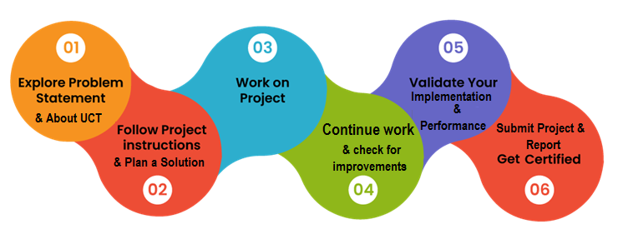

Overall it was a good experience, as we got to learn many things like how to analyze the data, data cleaning and data munching and how to represent the data.

I would like to take this opportunity and thank UCT for providing us with this opportunity. I would like to thank the online websites which we referred and my team member for giving the input and constantly working on the project along with me.

To my juniors I would like to suggest not to miss this opportunity and make proper use of it and not to miss any quiz.

# Introduction

## About UniConverge Technologies Pvt Ltd

A company established in 2013 and working in Digital Transformation domain and providing Industrial solutions with prime focus on sustainability and RoI.

For developing its products and solutions it is leveraging various**Cutting Edge Technologies e.g. Internet of Things (IoT), Cyber Security, Cloud computing (AWS, Azure), Machine Learning, Communication Technologies (4G/5G/LoRaWAN), Java Full Stack, Python, Front end**etc.

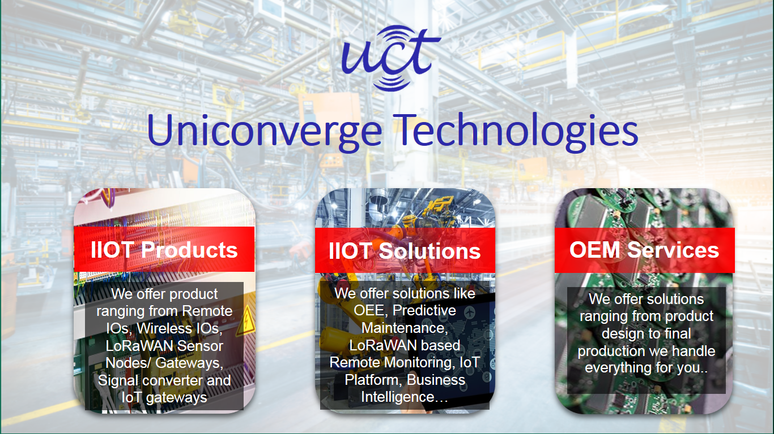

1. UCT IoT Platform **(****)**

**UCT Insight** is an IOT platform designed for quick deployment of IOT applications on the same time providing valuable “insight” for your process/business. It has been built in Java for backend and ReactJS for Front end. It has support for MySQL and various NoSql Databases.

* It enables device connectivity via industry standard IoT protocols - MQTT, CoAP, HTTP, Modbus TCP, OPC UA
* It supports both cloud and on-premises deployments.

It has features to  
• Build Your own dashboard  
• Analytics and Reporting  
• Alert and Notification  
• Integration with third party application(Power BI, SAP, ERP)  
• Rule Engine

 

1. **Smart Factory Platform (****)**

Factory watch is a platform for smart factory needs.

It provides Users/ Factory

* with a scalable solution for their Production and asset monitoring
* OEE and predictive maintenance solution scaling up to digital twin for your assets.
* to unleased the true potential of the data that their machines are generating and helps to identify the KPIs and also improve them.
* A modular architecture that allows users to choose the service that they what to start and then can scale to more complex solutions as per their demands.

Its unique SaaS model helps users to save time, cost and money.

 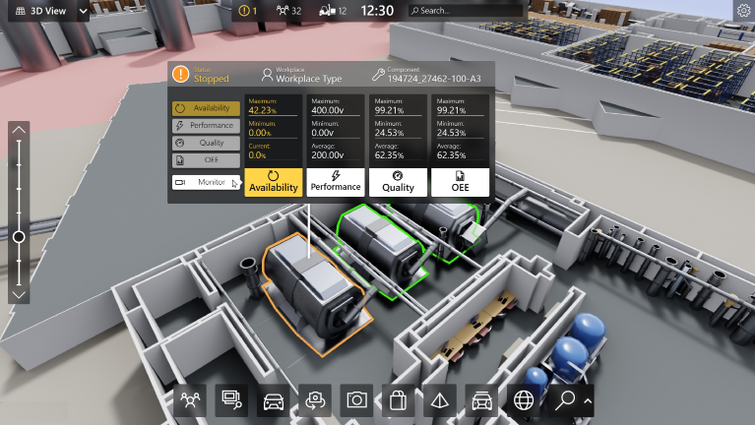

1. 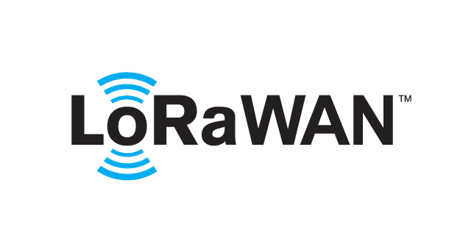 based Solution

UCT is one of the early adopters of LoRAWAN technology and providing solution in Agritech, Smart cities, Industrial Monitoring, Smart Street Light, Smart Water/ Gas/ Electricity metering solutions etc.

1. Predictive Maintenance

UCT is providing Industrial Machine health monitoring and Predictive maintenance solution leveraging Embedded system, Industrial IoT and Machine Learning Technologies by finding Remaining useful life time of various Machines used in production process.



## About upskill Campus (USC)

upskill Campus along with The IoT Academy and in association with Uniconverge technologies has facilitated the smooth execution of the complete internship process.

USC is a career development platform that delivers **personalized executive coaching** in a more affordable, scalable and measurable way.



Seeing need of upskilling in self paced manner along-with additional support services e.g. Internship, projects, interaction with Industry experts, Career growth Services

<https://www.upskillcampus.com/>

upSkill Campus aiming to upskill 1 million learners in next 5 year

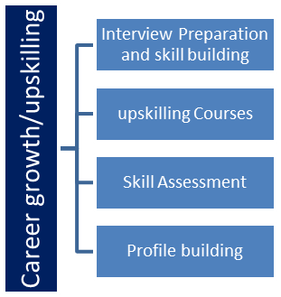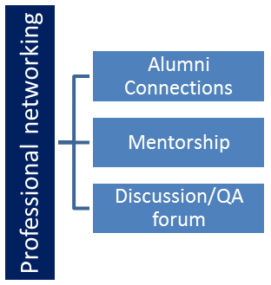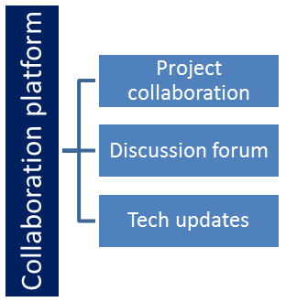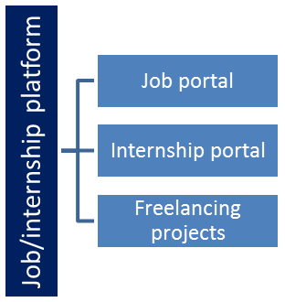

## The IoT Academy

The IoT academy is EdTech Division of UCT that is running long executive certification programs in collaboration with EICT Academy, IITK, IITR and IITG in multiple domains.

## Objectives of this Internship program

The objective for this internship program was to

 ☛ get practical experience of working in the industry.

 ☛ to solve real world problems.

 ☛ to have improved job prospects.

 ☛ to have Improved understanding of our field and its applications.

 ☛ to have Personal growth like better communication and problem solving.

## Reference

[1] https://www.softwaretestingo.com/traffic-signal-test-case/

[2] https://github.com/mratsim/McKinsey-SmartCities-Traffic-Prediction

[3] https://www.kaggle.com/datasets/utathya/smart-city-traffic-patterns

## Glossary

|  |  |
| --- | --- |
| Terms | Acronym |
| Smart City | Urban area which uses technology |
| Traffic Pattern | Recurring and predictable pattern of traffic |
| Junction | A point where two or more roads meet |
| Congestion | Heavy traffic conditions |
| Rerouting | Along a different route |

# Problem Statement

I am working with the government to transform various cities into a smart city. The vision is to convert it into a digital and intelligent city to improve the efficiency of services for the citizens. One of the problems faced by the government is traffic. You are a data scientist working to manage the traffic of the city better and to provide input on infrastructure planning for the future.

The government wants to implement a robust traffic system for the city by being prepared for traffic peaks. They want to understand the traffic patterns of the four junctions of the city. Traffic patterns on holidays, as well as on various other occasions during the year, differ from normal working days. This is important to take into account for your forecasting.

Transforming a city into a smart city and addressing traffic-related challenges is a commendable initiative. As a data scientist, here's how you can help the government understand and manage traffic patterns for the four junctions of the city:

1. Data Collection and Analysis:-Start by collecting historical traffic data for all four junctions. This data should include traffic volume, speed, and congestion information, ideally from several years, to account for seasonal variations.

2. Holiday and Special Occasion Analysis:-Create a calendar of holidays and special events for the city. Identify significant occasions that may affect traffic, such as festivals, parades, sports events, and major public gatherings.

3. Traffic Forecasting:-Develop predictive models that can forecast traffic patterns for the four junctions of the city. These models should consider factors such as time of day, day of the week, weather conditions, and upcoming holidays or events.

4. Public Awareness and Education:-Communicate with the public about the smart city initiatives and how they can contribute to better traffic management. Encourage the use of public transportation, carpooling, and alternative routes during peak traffic times.

# Existing and Proposed solution

Existing Solution:

1.Data Collection: Gather comprehensive data on traffic patterns, including volume, congestion, and factors like weather and accidents.

2.Data Preprocessing: Clean and process data, aggregating it into relevant time intervals.

3.Exploratory Data Analysis: Use visualizations to identify trends and anomalies, with a focus on understanding how holidays and special occasions affect traffic.

Proposed Solution:

1.Traffic Forecasting: Utilize time series forecasting models to predict traffic patterns for different junctions, taking into account holidays and special events.

2.Scenario Analysis: Assess how traffic varies during holidays and special occasions compared to regular days to plan for peak traffic loads.

3.Traffic Management and Optimization: Develop real-time traffic management systems that optimize traffic signal timings, provide dynamic updates, and reroute traffic during congestion.

4.Infrastructure Planning: Collaborate with urban planners to design infrastructure improvements based on traffic forecasts.

## Code submission (Github link)

## Report submission (Github link) : first make placeholder, copy the link.

# Proposed Design/ Model

This proposed design outlines a comprehensive traffic management system that leverages data, technology and user engagement to optimize traffic flow, enhance road safety and improve the overall quality of life in a smart city. The successful implementation of such a system can significantly contribute to the city’s efficiency and sustainability while addressing the challenges of traffic congestion.

## High Level Diagram:

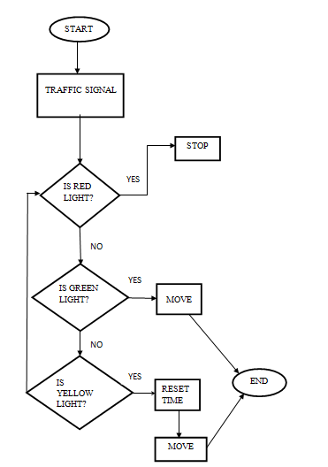

Figure 1: HIGH LEVEL DIAGRAM OF THE SYSTEM

1. Upgrade traffic lights and road sign to be equipped with communication capabilities to receive real-time data and adapt to traffic conditions.
2. Install smart traffic management systems at intersections, including cameras, traffic sensors and adaptive signal controllers.

# Performance Test

Performance testing is a crucial phase in the development and deployment of a traffic management system for a smart city. It ensures that the system functions optimally under various conditions, including peak traffic loads and unexpected scenarios. Here's a brief overview of how to conduct performance testing for such a system:

1. Define Performance Metrics:- Start by defining clear performance metrics and objectives. These metrics can include response time, throughput, resource utilization (CPU, memory, bandwidth), and system stability under heavy loads.

2. Load Testing:- Conduct load testing to assess how the system behaves under expected traffic loads. This involves gradually increasing the number of simulated users or devices to measure performance thresholds.

3. Stress Testing:- Perform stress testing to evaluate how the system handles extreme conditions beyond its normal capacity. This helps identify breaking points and weaknesses.

Effective performance testing ensures that the traffic management system can handle traffic peaks, holidays, and various other occasions as specified in the initial requirements. It also helps guarantee a positive user experience, system reliability, and efficient traffic management in a smart city.

## Test Plan/ Test Cases

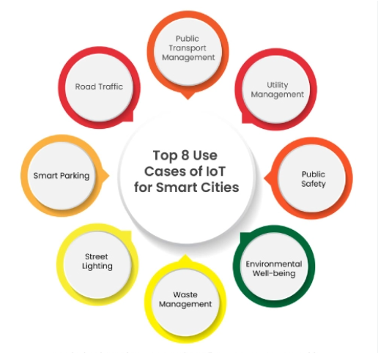

## Test Procedure

1. Data Collection:- Collect historical traffic data from various sources, including traffic cameras, sensors, GPS devices, and mobile apps. This data serves as a baseline for comparison.

2. Simulation:- Utilize traffic simulation software to model the current traffic conditions within the smart city. Implement proposed traffic patterns and control strategies in the simulation environment.

3. Traffic Pattern Optimization:- Adjust and fine-tune traffic patterns and control algorithms in the simulation to optimize traffic flow and achieve the defined objectives. Use machine learning and AI algorithms to predict and adapt to changing traffic conditions.

4. Real-world Testing: - Implement the optimized traffic patterns and control strategies in a controlled real-world environment within the smart city. Monitor and collect real-time data from traffic sensors, cameras, and other sources.

5.Data Analysis:- Analyze the data collected from both the simulation and real-world testing phases. Compare the performance metrics with the objectives and baseline data to assess the effectiveness of the traffic patterns.

## Performance Outcome

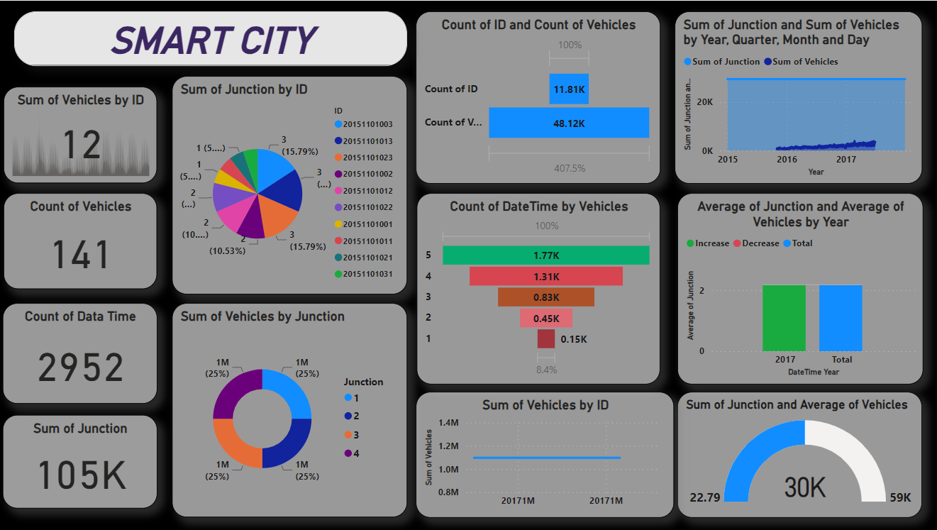

# My learnings

My involvement in the project to transform a city into a smart city and manage traffic patterns as a data scientist provides you with valuable skills and experiences that can significantly contribute to your career growth. Here are some of the key learnings and their potential impact on your career:

1. Data Analysis and Modeling Skills:-You will have gained expertise in collecting, cleaning, and analyzing large datasets to derive meaningful insights. These skills are highly transferable to various industries, including finance, healthcare, and e-commerce.

2. Predictive Analytics and Forecasting:-Your experience in forecasting traffic patterns can be applied to other domains, such as demand forecasting in supply chain management or predicting customer behavior in marketing.

3. Machine Learning and AI:- The application of machine learning algorithms in traffic management can be extended to solving complex problems in other fields, such as natural language processing, image recognition, and recommendation systems.

4.Data Monitoring and Decision:-Making Your experience in setting up real-time data monitoring systems and making quick decisions based on data can be applied to roles that require real-time analytics, such as financial trading or network security.

5.Problem-Solving and Critical Thinking:-Addressing traffic management challenges and finding innovative solutions will sharpen your problem-solving and critical thinking abilities, making you a valuable asset in any role that requires analytical thinking.

In summary, your experiences and learnings from working on a smart city project can not only elevate your technical skills but also provide you with a well-rounded skill set that is transferable to a wide range of career paths. Whether you choose to continue in urban planning, data science, project management, or explore other fields, your expertise in data-driven decision-making and innovative problem-solving will be highly sought after and beneficial for your career growth.

# Future work scope

The future scope of managing traffic in a smart city is vast, as technology and data-driven solutions continue to evolve. Here are some potential areas of future development and expansion in the field of traffic management for smart cities:

1. Connected and Autonomous Vehicles (CAVs):

- Integration of CAVs into the transportation network will be a significant focus. These vehicles can communicate with traffic infrastructure and each other to optimize traffic flow, reduce congestion, and enhance safety.

2. 5G and IoT Integration:

- The rollout of 5G networks will enable more real-time data exchange between vehicles, traffic infrastructure, and central traffic management systems. IoT devices can be deployed for better monitoring and control of traffic.

3. Advanced Traffic Control Algorithms:

- Further refinement of traffic control algorithms that can adapt in real-time to changing conditions. This includes predictive analytics to anticipate traffic congestion and adjust traffic signals accordingly.

4. Smart Parking Solutions:

- Enhanced smart parking systems that guide drivers to available parking spaces, reducing the time spent searching for parking and mitigating traffic caused by such searches.